Ship Ideas

Ship Basic Overall Ideas:

* Ships are made up from components and swappable parts. The hull of a ship determines how many components or parts it can have inside of it.
* Hull also determines the look of the ship and also the durability or health of it. The ship can be painted by the player using a paint editor (colour wheel etc.). Each hull will allow up for 3 colours on it at a time with a main colour, secondary colour and an accent colour. This will allow the player to have multiple ships that follow the same colour trend and style as each other.
* This whole ship system could be programmed using scriptable objects with the hull being the root object and the components being scripted. The hull could be scripted to include a mesh for the object, health etc and components applied to the ship will complement this. This is mentioned in more detail in the ship programming design document.
* You could upgrade from one ship, trading it in. Then, buy it for a cheaper price than you are buying it upfront. Tasks could be done to receive a ship.

Borrowing/Leasing:

* A ship could be borrowed for a cheaper price over a certain amount of days, weeks, months or years. If the ship becomes damaged there will be the cost of having to repair, it and extra.

Ship Insurance:

* Companies allow people/AI to pay so if their ship is damaged or broken, they will be covered for a certain amount of the price for it to be fixed or replaced.

AI Encounters:

* All ships in the galaxy follow the ship component system and so AI ships will also follow this. This means the player will have to analyse other ships to find out what components they have if they want to engage them in order to find weaknesses or flaws in their system such as the type of weapons they have.
* The player can intercept cargo haulers from other factions and loot them, although this could cause that faction to dislike the player faction unless the other faction does not know what happened, this is a potential for stealth missions on enemy ships, or transmission could be intercepted in an all-out space battle.

Ship Appearance:

* The ship from the outside must look and have the features to be able to actually function otherwise the components would hold in place and would be lost in outer-space, therefore the ship must have a exoskeleton to provide the measures that ensure a safe structure to the ship design. The ship out part could be customised in colour size and other variant factors such as number of turrets, visibility and other key important features.
* Also, the ships appearance could be down to the importance or role of the ship. For example, a military ship could have camouflage in which meaning it wouldn’t be important to appear nice. Whereas, a luxury car that could be brought separately mould have to appear nicely.
* The normal starting ship would consist of the basic needs rather than wants and more powerful items such as main turrets.
* Maybe have a rustic looking ship, a bit deprived and needs some fixing up. The more components and battles you enter could end up with some scratches and dents in the side of the ship. (This is probably quite a challenge to implement into the game).

Ship Component System:

* Every component allows certain interactions with the world. For example, a mining laser can mine asteroids, without this you could not.
* Components can have different tiers or levels to them, which increases their efficiency, speed or effect on the world.
* Components are categorised into three categories based on their function and their size. A specific hull can only support a certain number of each of these categories. The three categories could be “large”, “medium” or “small”. Weapons could be classed as “large” components for example and the hull of that ship may only support two of these “large” components.
* A ship has a reactor installed into it and this is crucial to a ships operation as every component will use a certain amount of power and will generate a certain amount of strain or heat onto it. This means the player will have to skilfully manage what they are using at one particular time.
* Along with these three categories, the ship will have an upgrade slot system so that x number of upgrades can be added to a ship and this will be determined on the actual ship hull and the reactor installed into the ship.

Illegal Components:

* Some components used by certain AI or Nations would think or have a set of rules only allowing certain components. If the components didn’t fit within the regulations of the land, the fines or other punishments could be dished out to those who broke the rules. For example, ‘Military Grade Hull’, this could be illegal as it’s as power as the Military’s power. Some nations could be more lenient about the regulations.

Large Components:

* These components are major components that define a ships major purpose. They will include large objects such as weapons or mining lasers and will physically be visible on the ships mesh at dedicated points on the ship’s base mesh such as platforms or slots for them to sit.

Medium Components:

* These components act as small additions to a ship’s functionality, they are often used in collaboration with larger components. For example, a gravity generator which could be used to gather ores from asteroids once they have been mined by the laser, rather than having to scoop them up. These will also include components such as armour and shielding.

Small Components:

* These components contribute utility features such as scanners and other “support” based items. Utilities that the usual player would need is a handgun and a torch these features would be very small, maybe a cabin and a locker for the players could be an upgradable component for the ship.

Expansion Components:

* These components offer expansions to ships. For example, they could increase the cargo space of a mining ship or cargo hauler. They are passive and do not require extra power.

Upgrade Components:

* These components are smaller benefits and abilities such as upgrades to other components, for example it can increase the amount of damage to a weapon or make the mining laser more effective by increasing its range or speed. These upgrades will cost energy from the reactor. (Look at programming code).

Special Components:

* These components can only be attached to a ship once and are often components such as the reactor, the hull, warp drive etc. Some components may also be only compatible with a certain type of ship. This could be a legendary item that you find from a drop, these items can also be upgraded when they are found so there isn’t a complete sense of feeling of ‘OP’ items and equipment.

Ship Interactions:

* The ship interactions could be a large variety of things such as controlling the inner components such as the oxygen supply and the power. These could be interacted by the players with certain role for example the engineer could be in charge of power and the mechanical side of things.
* Players have to use AI or themselves to attach cargo containers the side of the ship rather than an easy attachment, this could be made easier by using magnetic clamps etc.
* Interactions with cannons, players would have the ability to encounter another nation with contention between the nations allowing the players to kill the other using the cannon. Players must aim a key point of the ship making it more affective.
* Permissions, the permissions for certain things such as driving. This could be just for the captain and the pilot. The engineer would have certain access to the power and other components, this could stop griefing and the captain could also use this if a player were to be ‘AFK’
* Captain has the most amount of authority but doesn’t have the same amount of skill requirements for certain things such as repairing a hull. (this will be spoken more about elsewhere).
* 3rd person view, multiplayer. Cannoneer, pilot and other features such as an engineer who repairs things at and in the meantime can do other things if authorised by the captain.

On Rails Transportation:

* On earth there are hypothetical lanes that the planes, boats and other vehicles must take to ensure safety and no collision happen. This could be the main way the AI get around the planets. Players wouldn’t have to follow the regulations but the chances of crashing and most likely dying would increase significantly.
* Different regulations, hyper lanes would have a different speed limit maybe as an example.
* Lanes and transport that is open to the public would be accessible for most people endless the vehicle did not belong there, endless a very good reason for the vehicle it to be there.
* Military lanes would be very good as civilian ships could get in the way of, military vehicles can access the civilian lanes as long as it’s for a good reason the military would use the mode of transport differently because the components are much more dangerous and powerful than normal.
* More developed nations would have better and more detailed systems for the military and civilians to use making the mode of transport much more efficient in such a way.

Ship Fuel:

* There will be two types of fuel: Propulsion and Warp Fuel. Propulsion fuel will be used for propulsion and controlling forward velocity and inertia thrusters. Warp fuel will be used by the warp / jump drive to go much longer distances, such as between planets and stars.
* Fuel catalysts can also be used to have certain effects. These effects could include fuel usage decreases or perhaps faster speeds. It could also control the size of thrust particles and other variables of the particles.
* Fuel catalysts also control the colour of the ship’s thrust particles. These colours will relate to the flame tests for certain elements, so for example using lithium as a catalyst will emit a crimson thrust colour. The chart below shows a list of possible colours. The outer flame shows the start colour of the particle and the inner flame shows the trail of the particle as its lifespan occurs. If no catalyst is used, each type of thruster on the market will have a default thrust colour.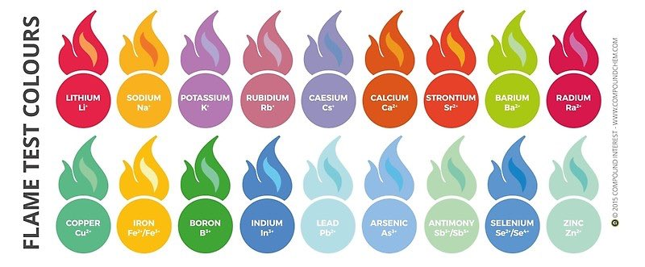
* If a ship runs out of a type of fuel, it will not be able to use functions of the ship that use that type of fuel. This would have to be resolved using a distress beacon of some kind.